

*Practical Singular Project Test.*

*Final Report*

*by*

**Jacques Mbuyamba**



Wednesday, 07 August 2019

**Acknowledgements**

It been very challenging for the past month me, I had to make extra effort and in the end it all paid out all thanks to Singular Team during my intern. I learn new technology that I believe will be a key to the success of my career as all. I will like to take this opportunity to thanks again every member of Singular team to be so friendly with me and their taught what it means to be a developer. And for those who went extra mile and helped me, encouraged me and I mention:

David Elliott who see where there is potential and give the opportunity.

Julian Springer who believe in me give the golden opportunity that is the kick start for my career and future.

James Smith who went extra mile to teach me some new technology and for that I am grateful.

Tawika Nyathi who was always there the troubleshooting error and give guidance.

Valentine Mthembu who share he knowledge in react and help troubleshooting during my intern.

Contents

**No table of contents entries found.**

**No table of figures entries found.**

# Chapter 1 Project Proposal

## Project Background

The software development industry is one most competitive and challenging career path around the globe. New developer needs to prove and demonstrate the capabilities and skills to be recognize into the community. This practical assessment aims to assess my abilities from the start to the end of the project.

The key Singular System aim to assess the following abilities:

* Planning skills
* Design skills
* Technical ability

## Project Aim

I have been tasked to create an internally used product order application, which allows for staff members to record their own details, as well as select from a range of 10 Products that they can order.

## Methodology and Approach

Software Development life Cycle and Agile principles.

I started off with the requirements and the front-end result and I try my best to meet this requirement.

I have litter experience especially in the front-end and dedicated all my effort to learn from others online resources. Try my best to have the best user output. And when it came to back end I think I more option as I some experience working with back-end.

## Project timeline

As mention above, I dedicated the first days to design and plan the back end, Since this project is meant to see my skills, I decided to use the text file as database as well as designing the SQL database. View the time constrained I had to make decision to drop the SQL database however I will still put it in this documentation.

Table 1: Time line

|  |  |  |
| --- | --- | --- |
| Task Name | Duration | Start |
| **Project initialization user Requirement** | **2 hours** | **Wend 31/07/19 07:00** |
| Determine user requirement | 30 mins | Wend 31/07/19 07:00 |
| Modelling Prospective site | 2 hours | Wend 31/07/19 07:00 |
| **Defining Data** | **1 Days** | **Wend 31/07/19 09:00** |
| Entity relationship Diagram | 1 Days | Wend 31/07/19 07:00 |
| Data flows & Direction flows | 1 days | Wend 31/07/19 07:00 |
| **Interface Design** | **1 days** | **Thu 01/08/19 7:00** |
| Planning pen drawing interface | 0.5 days | Thu 01/08/19 7:00 |
| Viewing another web design for comparation | 0.5 days | Thu 01/08/19/ 7:00 |
| **Language and tool decisions** | **1 days** | **Thu 01/08/19 12:00** |
| Text field design | 1 days | Thu 01/08/19 22:00 |
| Database design | 1 days | Thu 01/08/19 22:00 |
| Back-end C# | 1 days | Thu 01/08/19 22:00 |
| **Creation System** | **1 days** | **Fri 02/08/19 08:00** |
| SQL tables & Store procedures | 0.5 days | Fri 02/08/19 08:00 |
| **Programming** | **4 days** | **Fri 02/08/19 12:00** |
| ERD(Entity Framework structure) & testing | 0.5 day | Fri 02/08/19 12:00 |
| Business Logic (C#) & testing | 2 days | Sat 03/08/19 14:00 |
| API (ASP.net framework)& testing | 1 days | Sat 03/08/19 22:00 |
| React Front-end & troubleshooting, testing | 3 days | Tue 06/08/19 17:00 |
| Documentation | 4 hours | Wed 07/08/19 17:00 |

# Chapter 2 – Business Analysis

Be able to give to the customer a fine product that meet the requirement is always the main goal. However, to achieve this developer needs to work side by side with customer to achieve the success of the product. In order to ensure that the developer is still on truck, litter version with litter functionality should be first built to prove the concept and stand on the same ground with your customer.

# Chapter 3 – Data

For me to get an idea of what the system looked like, we had to define the data flows, structures, systems and formats that formed part of the greater whole. The fundamental idea in the definition of your data in an information system is to decide on a model and to not have to change it ever again. We spent a significant portion of the first week deciding how are we are storing our information and what the system needs to look like in order to be scalable and dynamic.

## Entity Relationship Diagram

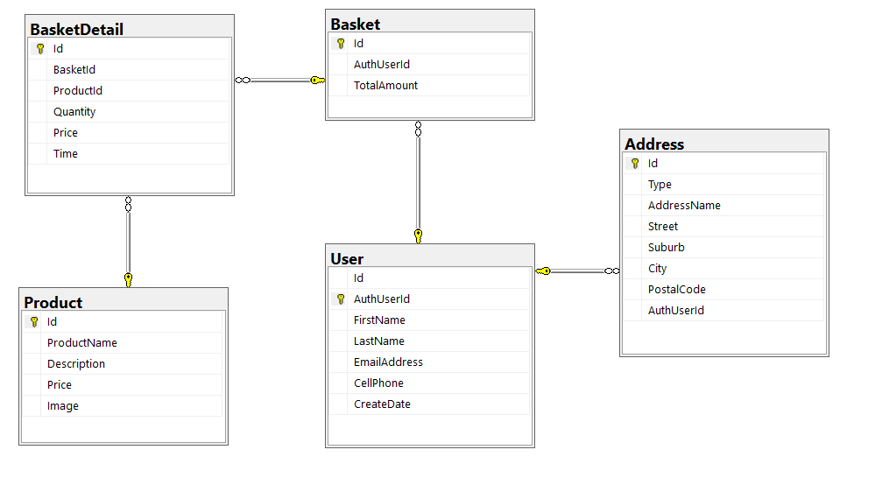

Figure 1: ERD